LAB TASKS FOR DAY 4
AWS Pricing Models and Their Prices
Pricing Model | Price/hr t3.micro | Commitment | Best For
On-Demand | $0.0104 | None | Unpredictable Loads
Reserved Instances | $0.00 | I year | Steady Workloads
Spot Instances | ~59% | None | Fault Tolerant Batch
Free Tier | $0.00 (up to 750 hrs) | 12 months | Learning and Labs

AWS Pricing Calculator and Cost Estimate Analysis
Configuration | Monthly Estimate ($)
EC2 (On-Demand) + S3 + RDS | 752.76
EC2 (Reserved 1yr) + S3 + RDS | 718.68
Savings with Reserved (3 year Projection) | 701.16

Cost Image Graph Not Loading
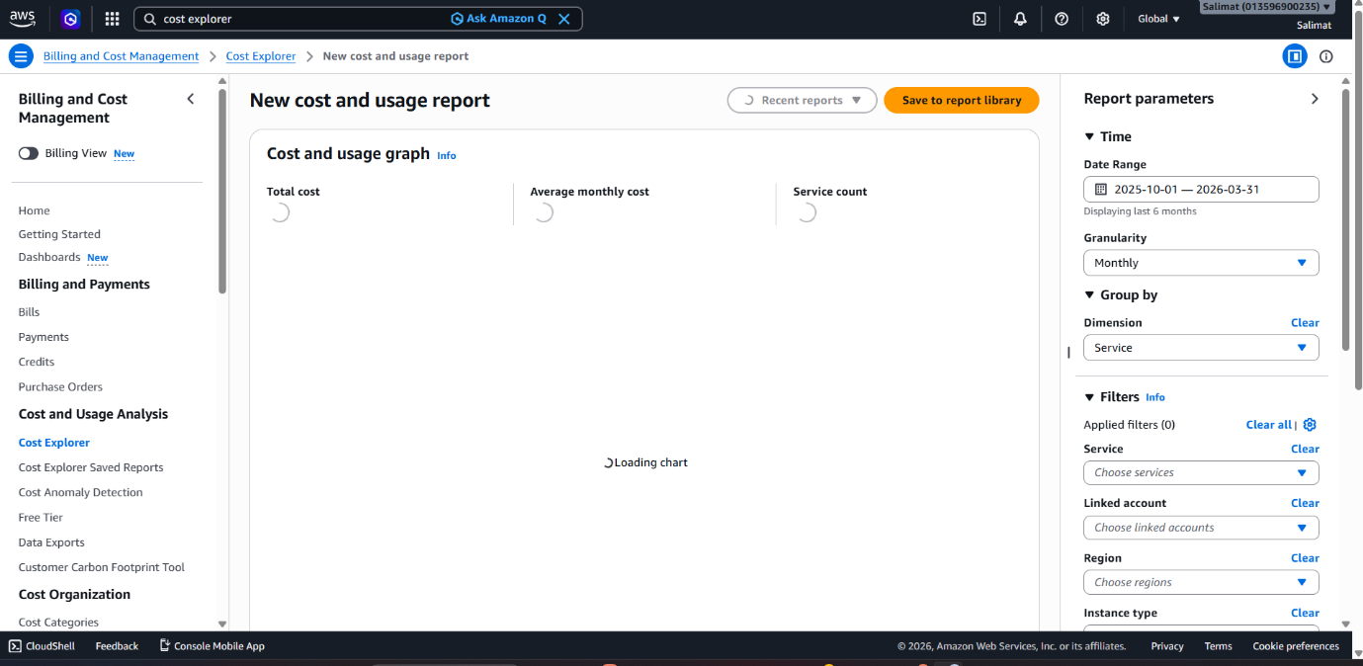

AWS Budget Created and Set to Zero Budget
